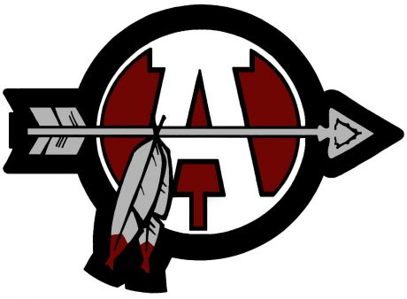
Marching Sequoits
T-shirt, Shoe & Equipment Order Form

DUE: June 2nd, 2014

Student Name: _____________________________________________

T-SHIRTS: $12 per shirt
Each member must order a t-shirt. Additional t-shirts for family and friends may also be ordered on this form.
Put quantity of each on the blank next to the size:
T-Shirt: S M L XL XXL

Number of shirts: _____ * $12 = $______ T-shirt total

DRILLMASTER/COLOR GUARD SHOES (if applicable):
All new members must order roll step or color guard shoes. If you are returning and your shoes from last year still fit, you do not need to order new shoes. We are being environmentally friendly this year and offering lightly used shoes. All guard members must order NEW shoes.
- Drillmaster Marching Shoes $30 (band or colorguard)

Shoe Size: _____________________

COLOR GUARD GLOVES (if applicable):
Color Guard gloves are NOT mandatory. If you would like to order gloves, please indicate the number of pairs and the size.
- Color Guard Gloves $14

Glove Size (S, M, or L): _____________________

Please combine the first band camp payment, t-shirt payment, shoe payment and equipment payment into one check payable to ACHS. Payment must be included with commitment form.

